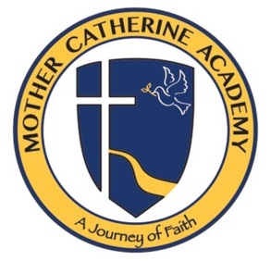
March 13, 2020
Dear MCA family,

As we enter the next two weeks apart from our school family, I want to encourage all of our families to keep a sense of normalcy. We believe that everything is according to God’s plan for the world. He has given us this time, with clear direction, to socially distance in order to become closer with family and our Lord. Pope Francis said, “We are called to rediscover what truly matters, what we really need, what helps us to live well and, at the same time, to identify what is secondary and that which we can easily do without”. As we socially distance ourselves from society, please take this time to reconnect with your family and God. I have included 2 weeks of morning prayer that we would do during this time. In addition there are prayers to celebrate St. Patrick and St. Joseph as well as Sunday readings and prayers. I am asking our students to lead their families in prayer every day and the attached resources are a great tool. Please also consider “unplugging” during this time and spend time as a family playing games, outdoor activities, and praying as a family. As always please consider MCA as resource for your family. Please feel free to email me during this time if you think we can assist. Our school, our families, our county, nation and the world will be in my prayers and it my hope that we will reconvene in 2 weeks spiritually stronger and focused on what is most important.

Remember the promise of Easter!

Peace in Christ<><,
Anthony J. Wojt
Principal MCA
mcacademyprincipal@gmail.com

